Testing Soap Service in Orasi Java Toolkit

## **This tutorial is designed to help a tester better understand how soapUI and Java/Selenium programming can be used in combination to create robust tests with web services.**

## Necessary Tools:

Before getting started there a few things you will need to access. In order to start this tutorial, you will need the free version of soapUI, an IDE (Eclipse is used in this demo), and you will want to access the API Demo, an Orasi repository. You will also be using the services provided at <http://www.webservicex.net>.

# Starting with core classes in API Demo

## SoapService:

The SoapService class is the primary class in which all interactions with Soap service are handled. Everything needed to form the Soap Request and validate the Soap Response is handled here. This class is not intended to be directly used by the test classes; instead, it is used as a Parent class or an extension to other classes which we will get into later.

## SoapServiceCommands:

The SoapServiceCommands class allows easy access to internal runtime commands that are used when you build the Soap Request by XPath. A sample of these commands are GetDate which will get the current date or RemoveNode which will remove the current XML node and all of its children from the Request.

# Creating classes for Service and Operations

For this example, we will be using three public webservice’s from the WebService website given at the top; specifically, the USZip service, the Australian Postcode service, and the UK location service which are all located in the standards and lookup data section. We want to use these three similar services to aid in the construction of proper hierarchal file management which will mimic how an actual professional project is set up.

**The three WSDL’s used:**

USZIP - <http://www.webservicex.net/uszip.asmx?wsdl>

This is a service that uses that Area Code, City Name, State Abbreviation or a Zip code to return relevant data from the input.

Australian Postcode - <http://www.webservicex.net/AustralianPostCode.asmx?WSDL>

This is a service that uses a Post Code and an Australian location to return relevant data from the input.

UK Location - <http://www.webservicex.net/uklocation.asmx?WSDL>

This is a service that uses County, Post Code, Town or a UK Address to return relevant data from the input.

## SoapUI:

From SoapUI, this is what our sample looks like when we create a new Soap Project with the USZip wsdl. The other services provided will look similar. The project is built up with the main project folder at top followed by a list of soap requests below it. Using the GetInfoByZip operation you can input the Zip Code into the request xml, and upon pressing play the response xml will return city information for that Zip Code.

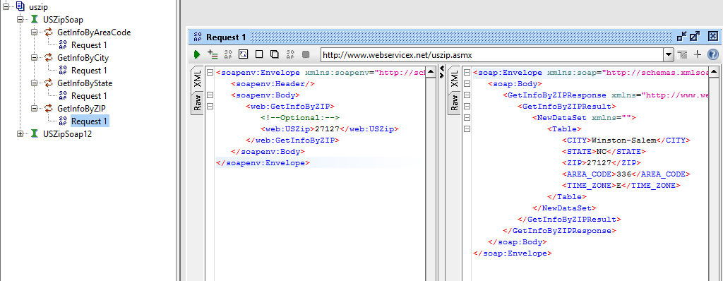

Our goal is to take this same process, and convert it into a Java format.

## Module package and Service Class’s:

In this example we will be dealing with three services in order to simulate enterprise level services where there can be multiple services that all fall under a single category. In this case our three services all deal with gathering geographical information. If you are working directly in the Orasi Toolkit, first create a new package in src/main/java/com called “LocationSearchModule”. This is where all our service java classes will go. This is going to be your “Service Package”. It will contain two objects, a class called USZip.java and a package called operations.

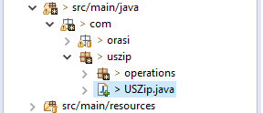

Since we are dealing with a single environment, the USZip class is very simple. In an enterprise field, you may need to have this class handle multiple environments, but for the purpose of this demonstration, we will keep it simple. All you need to do is extend this class into SoapService, and set the Service Name and Service URL to be used. The Service Name in this case is used for reporting purposes, while the Service URL is going to be the endpoint triggered and where requests are sent to.

**import** com.orasi.api.soapServices.core.SoapService;

**public** **class** USZip **extends** SoapService{

**public** USZip() {

setServiceName("UsZipService");

setServiceURL("http://www.webservicex.net/uszip.asmx?wsdl");

}

}